Romeo and Juliet CD Project
Directions: For this project, you will create a “CD” of songs that you feel represents the various events throughout the play. Follow the steps below in order to turn in a project that meets or exceeds the standards. This assignment should be completed with Prezi.
Step 1: Select 10 main plot points of Romeo and Juliet
Step 2: For each of the main plot points you chose, select a real song that represents that plot point and type the lyrics (edited if need be)
Step 3: Include an image of a work of art (include artist and title) that also connects to the song and plot point
Step 4: For each work of art and song, type a paragraph that explains how the lyrics, work of art, and plot point all connect.
Example:
Plot Point: Romeo is depressed because the woman he loves does not love him back.
Lyrics: “Grenade” by Bruno Mars
Gave you all I had and you tossed it in the trash
You tossed it in the trash, you did
To give me all your love is all I ever asked
'Cause
What you don't understand is
I'd catch a grenade for ya
Throw my hand on a blade for ya
I'd jump in front of a train for ya
You know I'd do anything for ya
oh oh oh oh oh
I would go through all this pain
Take a bullet straight right through my brain
Yes, I would die for you, baby
But you won't do the same
Art: “Head of Woman” by Picasso
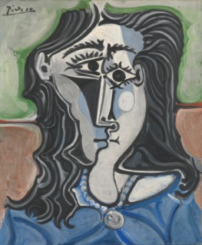
Connection:
Romeo is in love with Rosaline at the beginning of the play, but she does not love him back. He would do anything for her, but she will not date him. The song shows that the speaker would do anything for the person he loves, but the person he loves does not feel the same. This connects to the plot because of how Rosaline does not love Romeo back. Also, the art connects because the sad face and color blue (represents sadness) reveal the sadness that Romeo feels from not having the love of Rosaline that he wants.

